Motion Worksheet 2A Name__________________________
Frames of Reference
LT 1
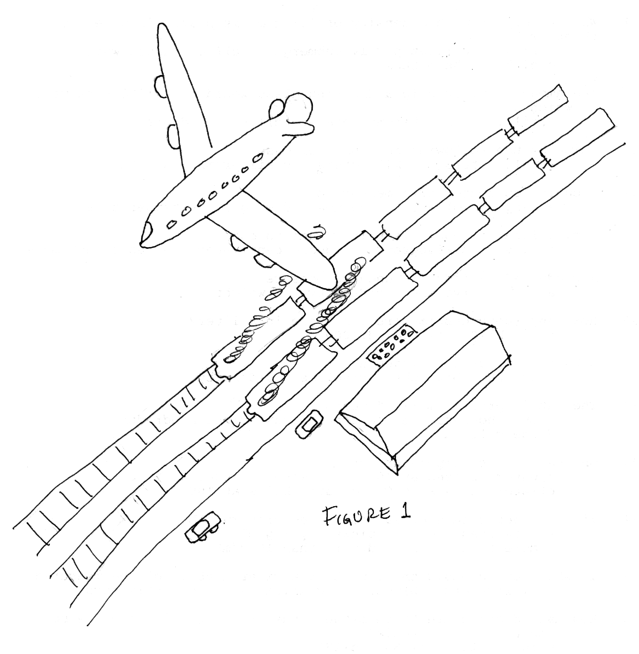

Train #1

Car #1

Frame of Reference Forward-------Backward
In Figure 1 below two trains are speeding past a train station with people waiting on the platform. Both trains are travelling at 75 miles per hour. The plane flying over is travelling at 300 miles per hour. The two cars leaving the station are travelling at different speeds. The first car is travelling 30 miles per hour, while the second car is travelling at 45 miles per hour. All of the moving objects are traveling towards the positive direction (direction can be + or -)

- At what speed and direction is the plane moving if the frame of reference is train #1 ?

Speed 225 mi/hr direction Forward

- At what speed and direction is train #1 moving, if the frame of reference is train #2 ?

Speed 0 direction : NA

- At what speed and direction is the 1st car moving, if the frame of reference is
the second car?

Speed 15 mi/hr direction Backward

- At what speed and direction is the 2nd car moving, if the frame of reference is
the plane?

Speed 255 mi/hr direction Backwards
Motion
- The change in the position of an object is called Motion

- To detect motion a frame of Reference is needed.

- Suppose a man is sitting perfectly still in a flying airplane.

  - The man is _________ with respect to the plane and objects inside the plane.
    - in motion
    - motionless

  - The man is _________ with respect to the Earth.
    - in motion
    - motionless

- If the distance is given in kilometers and the time in hours, the unit for speed is
km/hr

- If the distance is given in meters and the time in seconds, the unit for speed is m/s

- A person is standing in the bed of a truck that is moving forward at 20 m/s. The person is throwing apples forward at 15 m/s.

a. What is speed of the apple to someone in the bed of the truck with
the thrower? _______________ What is the direction?__________________

b. What is the speed of the apple to someone standing still on the
sidewalk watching?________________ What is the direction?________________

- A person is standing in the bed of a truck that is moving forward at 20 m/s. The person is throwing
apples backwards at 15 m/s.

a. What is speed of the apple to someone in the bed of the truck with
the thrower?_____________ What is the direction?___________________

b. What is the speed of the apple to someone standing still on the
sidewalk watching?____________________ What is the direction?_______________

